DJI Matrice User Guide

# DJI Matrice 100

Also the name of the flight controller,

alternative setups compatible with DJI SDK include A3 flight controller with lightbridge2 for 2.4Gz communication

# Flight Guide

Install the app on android from the weird URL

Tap, release then hold to use the DJI radio power button

# Flight Controller

N1 flight controller, however guides will refer to it as M100

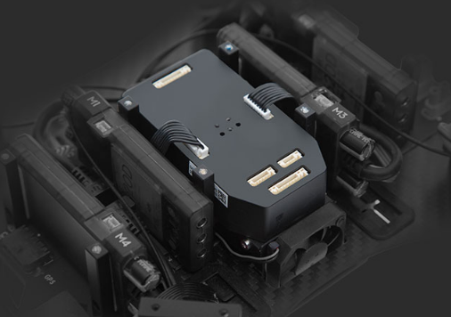

From <http://www.dji.com/matrice100/features#sub-feature>

M600 apparently uses the A3 flight controller

From <https://developer.dji.com/onboard-sdk/documentation/hardware-setup/index.html>

# DJI Guidance

## Features

Collision avoidance with flight controller

Guidance SDK features:

|  |  |  |
| --- | --- | --- |
| Name | USB | UART (115200 baud) |
| Velocity Data | Yes | Yes |
| Obstacle Distance Data | Yes | Yes |
| IMU Data (gyro + acc) | Yes | Yes |
| Ultrasonic Data | Yes | Yes |
| Greyscale Image | Yes | No |
| Depth Image | Yes | No |
| Subscribing | Guidance Assistant, API | Guidance Assistant only |

## Guidance SDK

Download: <https://developer.dji.com/guidance-sdk/>

Docs: <https://developer.dji.com/guidance-sdk/documentation/introduction/index.html>

### Interface

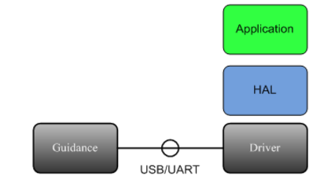

It appears that the Guidance SDK needs to interface with a computer via USB or UART

### USB

Subscribing data is done either by:

* Guidance Assistant Software (Desktop App)
* Guidance API (within the SDK code)

Detailed API documentation in above link, API is C style (not C++ style)

### UART

Subscribing done through Guidance Assistant

Protocol Frames:

|  |  |  |  |
| --- | --- | --- | --- |
| Field | Byte Index | Size（bit） | Description |
| SOF | 0 | 8 | Frame start number, fixed to be 0xAA |
| LEN | 1 | 10 | Frame length, maximum length is 1023 bytes |
| VER | 1 | 6 | Version of the protocol |
| RES | 5 | 40 | Reserved bits, fixed to be 0 |
| SEQ | 8 | 16 | Frame sequence number |
| CRC16 | 10 | 16 | Frame header CRC16 checksum |
| DATA | 12 | --① | Frame data, maximum length 1007 bytes |
| CRC32 | --② | 32 | Frame CRC32 checksum |

# Onboard SDK

Interaction between the onboard computer and flight controller

Guide: <https://developer.dji.com/onboard-sdk/documentation/quick-start/index.html>

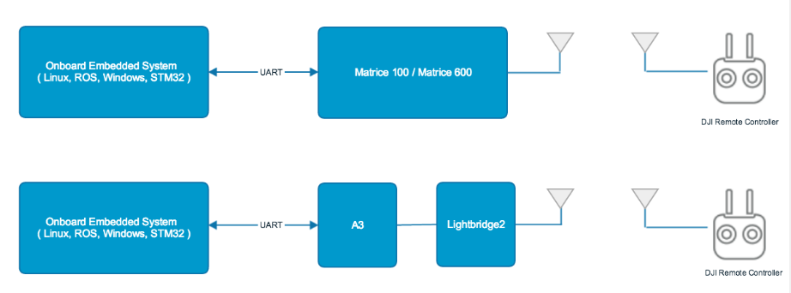

## Setup

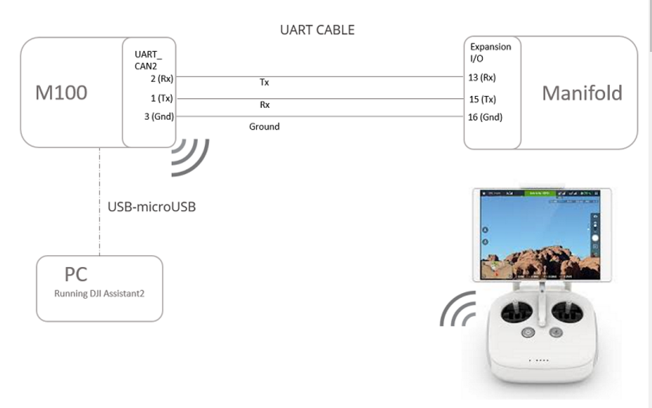

Needs board with UART output, or use the USB to TTL cable: <https://www.amazon.com/ADAFRUIT-INDUSTRIES-954-SERIAL-RASPBERRY/dp/B00DJUHGHI/ref=sr_1_5?s=electronics&ie=UTF8&qid=1466208644&sr=1-5&keywords=usb+to+ttl>

May need STM32, not sure what benefit it adds.

UDOO x86 has 2 UART ports, raspberry PI can use GPIO ports as uart

The M100/600/A3/N3 UART electrical interface is 3.3 volt TTL. You must ensure that your OES UART port is compatible to avoid damaging the flight controller.

# Mobile SDK

# DJI Manifold

Connects to Matrice via UART and has hardware similar to a Jetson TX1

|  |  |
| --- | --- |
| OS | L4T (Ubuntu based) (linux 4 tegra) |
| CPU+GPU | NVIDIA Tegra K1 SOC, released April 2014 <https://en.wikipedia.org/wiki/Tegra#Tegra_K1>  ARM Cortex-A15 MPCore R3 (confirmed ARM)  32bit architecture  8Gb DDR3L  4+1 ARM-Cortex A15 cores (5th core reserved for low power background tasks, invisible to OS)  192 Cuda cores |
| I/O | USB, Ethernet, Mini-PCIe, HDMI, UART, SPI and I2C ports |
| Library support | CUDA, OpenCV, ROS, DJI Onboard SDK |
| Flight Data access |  |
|  |  |
|  |  |
|  |  |

Alternative OES (onboard embedded systems) include:

STM32 Variants, UDOO x86 variants, raspberry Pi, other Tegra boards

# Software Environment

Have SDK examples of: <https://developer.dji.com/onboard-sdk/documentation/github-platform-docs/PureQT/README.html>

Not clear whether this is for onboard system or ground station